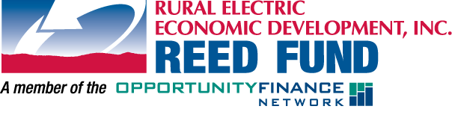
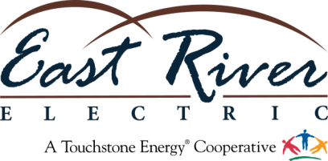
NEWS RELEASE

For immediate Release: November 19, 2014
Contact: Chris Studer, Cooperative Communications Manager
East River Electric Power Cooperative
Office: 605-256-8016 Cell: 605-270-4812 cstuder@eastriver.coop

East River Electric and REED Fund award $1 million loan to GROW South Dakota

SISSETON — East River Electric Power Cooperative’s Rural Electric Economic Development (REED) Fund has announced a $1 million loan to GROW South Dakota. The loan was officially closed Nov. 19 and will provide supplemental funding to the organization’s housing loan programs which provide affordable housing options to low-income families.

“East River Electric, its member cooperatives and the REED Fund work to grow our rural communities and make a positive impact in South Dakota and we’ve always been appreciative of the work GROW South Dakota has done to assist people in rural areas of the state,” said REED Fund manager Linda Salmonson. “We’re pleased to be able to partner with GROW South Dakota to provide housing options to people in rural South Dakota.”

GROW South Dakota is an umbrella organization under which many different services are provided. The organization provides funding for programs and initiatives dealing with community, housing and economic development.

“GROW South Dakota would like to thank the REED Fund for their partnership. We are excited to continue to build our housing loan fund to meet unique loan needs in South Dakota.” said GROW South Dakota CEO Marcia Erickson.

The REED Fund was established by the electric cooperatives in eastern South Dakota and western Minnesota in 1996 to enhance economic development in the region.

-30-

East River Electric is a wholesale electric power supply cooperative serving 24 rural electric cooperatives and one municipally-owned electric system, which in turn serve more than 92,000 homes and businesses and about 250,000 consumers. Our 40,000 square mile service area covers the rural areas of 41 counties in eastern South Dakota and 22 counties in western Minnesota. This institution is an equal opportunity provider and employer.

GROW South Dakota is a statewide non-profit organization serving rural communities to improve the quality of life through housing, community, and economic development. For more information about the housing loan programs visit www.growsd.org or call (605) 698-7654. GROW South Dakota is an equal opportunity lender, provider, and employer.

