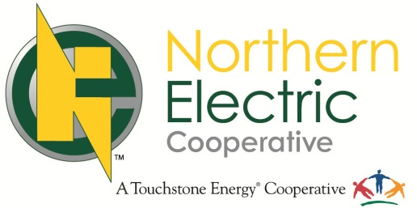

NEWS RELEASE
For immediate Release: December 30, 2014
Contact: Erica Sperry
Northern Electric Cooperative
Phone: 605-225-0310 Email: esperry@northernelectric.coop
Frederick Development Corp. receives loan through Northern Electric Co-op
FREDERICK — Two new rental units have been built in the northern Brown County community of Frederick thanks in part to loans from Northern Electric Cooperative’s Rural Electric Economic Development (REED) Fund and Grow South Dakota. The Frederick Development Corporation received a $90,000 loan through the REED Fund and another $90,000 loan through Grow South Dakota to build the units because of a severe housing shortage in the community. The loans were closed Tuesday, Dec. 30.
“We’re proud to be able to help Frederick Development Corporation to provide more housing options,” said Jim Moore, CEO/General Manager of Northern Electric Cooperative. “We’re committed to growing our rural communities, and we’re happy to be a part of this exciting opportunity to make a difference in rural South Dakota.”
There’s a limited supply of affordable housing in Frederick. More than half of Frederick’s teachers commute from Aberdeen or other communities, and this project will add more options for teachers, retired people or others who want to live Frederick.
Each unit is 988 square feet and feature two bedrooms, one bath and a single attached garage. The units are centrally located in Frederick within walking distance of the school and Main Street businesses.
-30-
This institution is an equal opportunity provider and employer.

