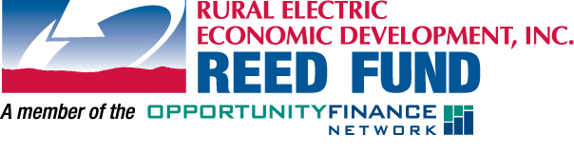

FOR IMMEDIATE RELEASE:
Ward, SD
August 21, 2013
Contact: Betty VanDerWerff
Sioux Valley Energy
605-534-3535
betty.vanderwerff@siouxvalleyenergy.com

The Town of Ward Receives $25,000 Loan from Sioux Valley Energy’s REED Fund

The Town of Ward was recently given a helpful hand on August 21, 2013 when Sioux Valley Energy issued a Rural Electric Economic Development, or REED, loan to The Town of Ward. The funds will be used to install new sidewalks, curb and gutter on the Main Street of Ward for the safety of residents and customers.

Working closely with local banks, other loan funds, state and federal agencies to finance community and economic development projects, Sioux Valley Energy provides gap financing from REED to help businesses startup or expand, create jobs and help communities improve facilities, services and infrastructure.

Tim McCarthy, Sioux Valley Energy CEO, says that providing funding to the Town of Ward is a great opportunity to positively impact the lives of many. “In today’s economy, employment and economic development continues to be challenging, so being able to assist through the REED Fund is very gratifying for us, knowing we are making a difference in our small communities and rural areas.”

Approximately 88 percent of REED’s lending is established in communities of less than 4,000 people and 95 percent of REED-financed projects have local ownership.

“One of Sioux Valley Energy’s core principles is Commitment to Community and the REED Fund is a good example of how we support local economic development,” says Tim McCarthy.

If you are planning a new business or looking to expand, or if your community needs financing for facilities or services, please contact Sioux Valley Energy at 605-534-3535 for an application or REED at (605) 256-8015 for more information.

